Unit 4 Calendar
Human Trafficking
Child Soldiers

We are our brother’s keepers??

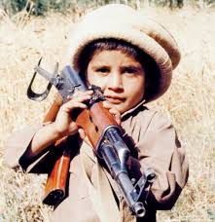
DUE DATES
Watch video Blood Diamonds # 11 – March 17-20
Research # 2 & # 8 is due – March 28
Take part in a book discussion on one of the three books # 1 & 3 & 7 Due - March 31
Discussion of UN and US policies # 4 - April 3
UN and US policy discussion # 4 – April 8
Deconstruction # 6 - April 10
Oral Presentation # 5 - April 14-17
Essay Preparation # 9 - April 23
Essay due (1750 -2000) # 10 – April 28

